Safety Report
8th Intercollegiate Rocket Engineering Competition
(2012-2013)

California State University, Los Angeles

Sonic Eagle

By
Elvia Cortes

May 26, 2013



MECHANICAL ENGINEERING DEPARTMENT
CALIFORNIA STATE UNIVERSITY LOS ANGELES
5151 STATE UNIVERSITY DR.
LOS ANGELES, CA 90032

Sonic Eagle Safety Report

Introduction
California State University Los Angeles will be entering the Sonic Eagle (25,000 ft category) in the 8th Intercollegiate Rocket Engineering Competition 2012-2013. The Sonic Eagle is a single stage with a dart, solid propellant sounding rocket. Details of the rocket are outlined in the technical report.¹ This report describes the safety processes for person(s) fabricating, building, operating, testing of the rocket, rocket components and/or supporting systems. This report is posted on the RS&T website (rsandt.com). It is in the reports section dealing with safety.

General Safety
Student participants are educated on University safety requirements and applicable safety codes. All CSULA safety regulations are applicable when working on CSULA campus². All work conducted outside of the university shall follow all city laws, state laws and national laws. All typical industry safety standards are expected to be followed at all times, unless they override school, state and/or national regulations.

- Know where any first aid kits are and know what is in them.
- Always be alert and stay alert in the fabrication lab.
- Do not drink/eat/run around or engage in any unsafe behavior in the lab
- Wear appropriate attire when operating equipment. Secure long hair when working around rotating or moving equipment, open heat sources, wear proper shoes where drop hazards exist, etc.
- Use safety glasses during all fabrication activities.
- No unsupervised use of laboratories without prior authorization by the Faculty Advisor/Mentor.
- No working alone in the laboratories.
- All equipment, chemicals and tools must be returned to original storage after use.

Any member of the Sonic Eagle team, liaison, student or faculty, has the inherent right to halt any launch or testing activity if he or she has a safety concern regardless of the perceived magnitude of concern. When a team member raises a safety concern, activities shall not continue until the safety concern has been resolved.

Earthquake Safety
- In case of an earthquake during fabrication, shut down all activities and evacuate the building.

Electrical Safety
- Never work with electrical equipment when any part of you is wet.
- Never work with any equipment that has exposed wires.
- Unsafe or hazardous electrical conditions in the fabrication laboratory must be reported to the Faculty Advisor/Mentor.

Fire Safety
- No open flames are permitted in the laboratory, e.g., no lighters or matches may be used.
- Know where the fire extinguisher(s) is for the lab.
  - Usage:
1. Remove from wall.
2. Pull pin.
3. Point at base of flames.
4. Squeeze handle

Chemical Safety
- Any unsafe or hazardous conditions in the lab such as chemical liquid spills must be immediately reported to the Faculty Advisor/Mentor.
- Use of safety glasses is mandatory for all use of chemicals.
- In the event chemicals or foreign objects enter the eyes, rinse eyes with water for 15-20 minutes at eye wash station. Then seek medical attention. Note: It is important to keep eye lids open. Support person(s) can assist in holding eye lids open. If contact lenses are worn, they must be removed.

Emergencies
- Know where the (nearest) phones are in the VEC building and Dial 911 or during working hours (7:30 AM to 4:30 PM) calls should be directed to extensions: 3-3527; or 3-3531. All emergencies after hours should be directed to the Public Safety Dispatcher at 3-3700.
Flight Safety
Section I
The CSULA Team implements several safety-enhancing techniques for their rockets. CSULA’s rockets use canted adjustable fins to obtain self induced roll stability. The launch rail system has elevation and azimuth control to improve desired rocket trajectory (even under wind conditions). On-board flight hardware with programmed software is used to control parachute deployment at desired altitudes and the wind profile is measured in order to control rocket impact.

- The Sonic Eagle has fin cant angle adjustments to achieve the desired roll rate. The burnout roll rate is approximately one third the burnout pitch / yaw natural frequency; yielding 10 roll revolutions during boost phase respectively. As long as the resonance frequency is not obtained, fin cant angles will improve the safety of the rocket by providing additional stability. The roll rate will minimize trajectory errors that are due to body-fixed misalignments. The fin cant angle is determined using aerodynamic strip theory.

- CSULA utilizes a combination of tools and information: tethered weather balloon measurement system, MS Excel and visual basic based trajectory program (SkyAero) and local wind data provided by the FAA, custom launch rail system. The tethered weather balloon system and local wind data from the FAA allow the team to determine winds at different altitudes. Those winds are then input into SkyAero with other launch conditions and Sonic Eagle specifications and motor thrust curve data. SkyAero outputs the required azimuth and elevation launcher angles for a desired landing point. The launch rail is then adjusted to the azimuth and elevation angles required to achieve the desired landing point.

- To further improve the rocket trajectory, hardware and software are used to control the drogue and main parachute deployments. First, our second stage parachute is deployed to slow down the rocket and precisely reach an apogee at 25,000 feet. The second stage parachute is deployed in a reefed condition to obtain a relatively high descent rate and to minimize the drift distance. It is disreefed with line cutters at about 1,000 feet AGL to ensure a soft impact. The first stage uses a drogue and main parachute combination. The drogue is deployed during ascent to give a high descent rate. The main parachute is deployed about 1,000 AGL to ensure a soft impact. Ultimately, a more controlled trajectory leads to enhanced safety by preventing dangerous hikes over hostile environments to recover the rocket.

Generalized Standard Procedures
Below are generalized standard procedures that have been established for individual systems to increase safety and proper operation of the rocket and launch rail. Detailed procedures are developed by individual teams.

- Trajectory Procedures
  - Call-in for local wind data from FAA.
  - Determine wind at ground level from pilot tether balloon system
  - Plot inputs into SkyAero
  - Relay desired elevation and azimuth angles.

- Launch Pad Procedures
  - No power shall be connected to rocket ordnance until the last time prior to launch.
  - Load the rocket onto the launch rail (ensure the rocket slides freely up and down the rail before connecting igniters).
  - Activate onboard flight computers when the rocket is in the vertical position.
  - Carefully connect the launch wires to the leads.
  - Continuity check at the local station.
  - Our people (both students and advisors) should all wear their CSULA T-shirts at all times when at the launch site. This is to facilitate tracking our people, especially around the launch pad.
  - The minimum crew working around the pad should carry a walkie-talkie for communication with our CAPCOM. This precludes the necessity of walking out to the pad to answer a simple question, and therefore is much safer.

- Launch Rail Setup
  - Assemble the launch rail per detailed instructions.
  - Tighten all tension wires after the system has been assembled.
  - The number of personnel working around the launch pad shall be minimized while rocket is on pad.
  - Once the rocket is loaded and erect, adjust the launch rail to trajectory team’s desired orientation.
  - Spray the riding lugs with Teflon

- Motor Assembly Procedures
  - Follow outlined detailed motor assembly instructions.
  - Load the motor into the casing.
  - Install the electrical matches into the motor.
  - Install motor retainer to prevent the motor casing assembly from falling out the aft end of the rocket.
  - Treat all items with extreme care when handling.
  - There is a minimum of (2) people allowed to work with motor assembly at one time.

- Parachute Packing Procedures
  - Fold the parachute (drogue or main) into halves and place cord into the last sections of the parachute folds.
  - Wrap the cords around the parachute (do NOT tangle) and put inside parachute holding bag.
  - Check all attachment points along the rocket to the parachute and from the parachute to the shock cord.

- Payload & Electronic Procedures³
  - All batteries and power sources must be charged.
  - Ground Test electronic systems prior to bringing the rocket to the pad.
  - Check all connections of flight and power hardware to electronic payloads.
  - Lens caps must be open for all still and video cameras.
  - At the pad, make sure that all electronics are functioning properly.

- Recovery Procedures
NOTE: All flight ordnance must be expended in flight.
This includes upper stage rocket motors, line cutters, parachute expulsion charges, etc. It’s a good idea for the flight computer to issue dual commands to all such devices in flight. The issue is
a hazard to recovery personnel if they pick up a rocket with
active ordnance. It’s possible that a stray static charge could set
off any unexpended ordnance.
  - Travel in pairs. All pairs must have visual contact with a member of another team at all times.
  - Use all (5) senses at all times.
  - Each person shall carry a minimum of 1 liter of water when recovering the rocket.
  - Proper attire and gear must be worn when recovering the rocket.
Walkie Talkies
  - Make sure the batteries are fully charged
  - Both walkie talkies should be on the same channel.
  - Test walkie talkie before departure.
  - At the end of each statement the speaker must say “over” to ensure that the other individual is aware that they have completed statement.
GPS Receiver
  - Make sure the battery is fully charged
  - Find current location and elevation by pointing the antenna towards the sky and recording the data.
  - To recover the rocket, input the location of the rocket into the location field (latitude and longitude) and save. (Follow the Magellan eXplorist 400 manual instructions)
  - Use the map provided by the GPS receiver from the current location to where the rocket is to find rocket.

- Procedure after finding rocket
After finding rocket parts a recovery team should always
  - First, visually inspect the items on the ground. If
relevant, photograph them.
  - Using the key, turn the ordnance arming switch to
DISARMED before further handling any hardware. In case of unignited ordnance this will make it safer to transport.
  - We should mark and label on the rocket's external skin
around the hole for the arming switch the positions for "disarmed" and "armed".
  - The checklist for recovery teams should include the arming
switch key.

After ordnance is disarmed, it is “safe” to handle the rocket for transport back to the home base. However, it is good practice to aim the rocket ordnance upward, as a further safety measure. In case of accidental discharge the ordnance will not be facing anyone and will shoot upward minimizing the chance of injury to any person transporting the rocket.

Design Requirements

The 2011 Intercollegiate Rocket Engineering Competition video⁴ provides ample motivation for better flight safety. A simple analogy shows why this is important.

What’s the comparison between the kinetic energy of our rocket and an ordinary car? Assuming our rocket is at the first stage burnout and the car is traveling at about 60 mph, the KE ratio is:
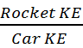 = 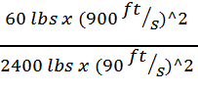 = 2.5

The rocket has 2.5 the kinetic energy of a car; of course nearer to the ground the rocket has less kinetic energy. Nonetheless, the chemical energy associated with unburnt propellant could, after impact, continue to release potentially dangerous fumes and heat.

a) Means to Command
ESRA will require that all boosters be fitted with a means to command early deployment of recovery parachutes in the event that a catastrophic boost phase failure causes the rocket to pitch over to an approximately horizontal attitude. It should be implemented for all future CSULA rockets whose burnout KE is greater than 0.1 a car’s KE as defined above. When done properly, a magnetometer input axis is aligned with the rocket's symmetry axis, and the threshold for emergency parachute deployment is zero output from the magnetometer.

b) Hang Fires
To ensure safety around the launch area, only essential personnel shall be allowed in the pad area after the igniter is installed. To make all aware of a pending rocket launch and to ensure that safety distances are maintained, an audible 10 second countdown shall be implemented. In case of a misfire or hang fire, all subsequent launch attempts shall also be preceded by a 10 second countdown. No one shall approach the pad area until one minute (60 sec.) has elapsed after the final launch attempt. The Team Safety Officer shall ensure that a functional fire extinguisher is available on the launch pad.

c) Ordnance Circuit Arming Procedures
The circuits that initiate either black powder charges for parachute expulsions or ignite a rocket motor are all battery powered. Circuit arming general safety considerations strongly suggest that these batteries be electrically isolated from their powder charges and igniters while personnel are in proximity to the rocket.

c) Safe Viewing Distance for Rocket Launches
Introduction
Everyone, it seems, wants to get as close as possible to watch a rocket liftoff. But, a little reflection reveals that this can be very dangerous. Another dangerous habit is assuming that the hazards associated with small Boy Scout Estes rockets are the same as for an advanced ESRA rocket. They're not.
The purpose of this memo is to explore the consequences of these thoughts.

Analysis
First, consider an ordinary rocket flight during which there are no failures, only normal trajectory errors. For nearly vertical flight, the significant trajectory errors all involve rotation of the velocity vector near the ground. Since all rockets have similar trajectory errors, impact errors are proportional to apogee altitude. In figure 1, this is shown as "90% Impact Point Capture line. That is, if 90% of all randomly perturbed trajectories are to land in a square field, then the field size for this is that shown. This curve can be thought of as a generic trajectory dispersion analysis. Most interesting is the fact that field size depends linearly on the burnout energy.

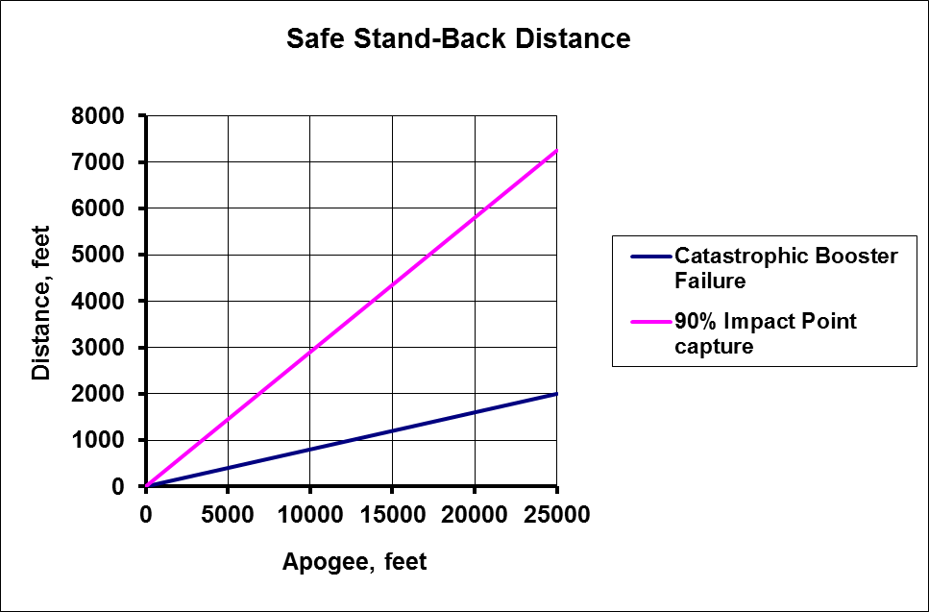
Figure 1: Safe Viewing Distance

It also seems reasonable that the degree of danger when there is a malfunction early in boost is also proportional to the rocket's energy, in this case largely chemical energy. After witnessing a
flight of ESRA class rocket in which a major malfunction occurred
prior to burnout, the blue line in the figure is intended to
envelope these.

Recommendation
The blue line will be used for safe personnel viewing operations
of rocket launches.

References

- Pathan, A., Liu, B., Ramos, J., Suppanade N. D., Cortes, E.,
Khalighi, S., Garnica, S., Lee, Y., Wells J. D. 2013 June.
Experimental Sounding Rocket: Sonic Eagle

- CSULA Environmental, Health & Safety (EHS). College of Natural and Social Sciences, California State University Los Angeles. Jan 26, 2012 <www.calstatela.edu/univ/ehs/index.php>

- Sinclair, Doug. 2012 Oct. 8th Intercollegiate Rocket Engineering Competition: Safety-critical Wiring Rules.
<http://www.rsandt.com/media/WiringRules.pdf>

- Koehler. "The 2011 Intercollegiate Rocket Engineering Competition (IREC)." 13 August 2011. Online video clip. YouTube. Accessed on 22 April 2013.
< http://www.youtube.com/watch?v=Ry9P_FSbn3c>

- Federal Aviation Regulations, Part 101, Federal Aviation Agency

- 1122 Code for Model Rocketry, American National Standards Institute / National Fire Protection Association

- Tripoli Safety Code for Advanced Rocketry, 01 August 1987

- Model Rocketry Safety Code, Estes

- “Trajectory Simulation for CSULB Sounding Rockets”, Oscar Mejia,
2008 AIAA Region VI Student Research Competition

- “A New Wind Sensor for Rocket Launches”, Mohamed Samir,
Mohideen Faisal Buharie, 2008 AIAA Region VI Student Research
Competition

- Model Rocket Safety Code. National Association of Rocketry, May
30, 2010 <http://www.nar.org/NARmrsc.html>.

- Buharie, Mohideen Faisal, Safety Report 6th Intercollegiate Rocket
Engineering Competition CSULB, 2009-2010

Appendices

An ESRA project implies significant ground testing of components to support rocket design and operational processes. These include

- Thermite-enhanced igniters
- Parachute deployment
- Parachute disreefing line cutters

NOTE: Safety Officer MUST be present while all tests are conducted

Copper Thermite Testing

- Mixing Procedure:
- Obtain steel plate and place it on the work table
- Set Scale on plate with a piece of filter paper on it
- Open one jar at a time, scoop small amounts of powder(using a metal spoon) and place it on the filter paper until desired amount is obtained
- Make sure to close the lid after obtaining sample
- Label the filter paper with the measured amounts of powder
- Obtain a stainless steel bowl and mix them together until it is an even mixture
- Place mixture inside the silk bags
Safety:
- Work in a static-free environment and wear anti-static straps
- Make sure there is no wind
- Stay away from any sparks or open flames
- Wear a full face shield
- Testing Procedure:
- Dig a hole in the ground away from people and objects. It should be about 1 foot deep and wide.
- Uses the Estes electric igniter to light up the thermite
- Place igniter clips inside the tea bag (KEY ALWAYS OUT UNTIL READY FOR TEST)
- Wrap bag around wire, tape it together and place it inside the hole
- Walk 30 feet away
- Insert key, push down firmly and hold until thermite ignites
- Remove key
Safety
- Stay away from electrical poles, trees, buildings, dry grass or weeds
- Do not test if there is wind
- Stay 30 feet away from the testing location
- If thermite does not ignite, take key out of controller, and wait 10-15 minutes before walking over to it
- Must have at least 2 people present while testing/mixing thermite in case of an emergency
- Use sand/soil as an extinguisher if needed
- Find out if it is legal to conduct the thermite test at location

Parachute Deployment Testing
Procedure:
- Place rocket facing up tilted slightly sideways
- Configure rocket the same way as it will be for a flight. Pack Parachute and recovery harness exactly the same as it would be for launch
- Place a small measured amount of black powder inside
- Connect to an electric igniter
- Stand 30 feet away and ignite
- Repeat steps 1-5 until desired amount of black powder is found
Safety:
- Stand 30 feet away from the testing site
- Use an open space for testing
- Wear full face shield and anti-static straps
- Stay in a static free environment
- Only a small amount of black powder should be brought out to the field
- Black powder container should be kept on the ground
- Open and close black powder cans very slowly
- Make sure no grains are lodged in cap threads when opening and closing can

Disreefing Line Cutter Testing:

Testing:
- Slide O-ring into the bottom of the cable cutter
- Insert cable tie through the hole of the cable cutter
- Insert the shearing piston
- Measure 0.1 mL of black powder using the centrifuge tube provided
- Insert black powder inside the cable cutter
- Insert an insulated match
- Slide the Kevlar thread loop over threads of screw and attach the other side to your provided connection point (Anything heavy enough to keep it in place, such as a water bottle)
- Slide hex screw over match leads and screw into cable cutter.
- Attach match leads to an electric igniter
10. Place the cable cutter inside a cinder block (with dimensions of 16x8x8)
11. Ignite line cutter
12. Repeat test with 0.75 mL and 0.15 mL, and using black powder grain Fg and FFFg to find optimal amount and grain type.
Safety:
Same as stated above for the parachute deployment testing.
Results:
For best results 0.1 grams of black powder grain FFFg will be used.

Black Powder  Grain | Amount of  Black Powder (ml) | Did it cut  the line? | Comments
Fg | 0.1 | no | Two trials, both failed.  Grain is coarse, the piston in the line cutter was a tight fit
FFFg | 0.075 | yes/no | two trials, 1 worked 1 failed
FFFg | 0.1 | yes | Two trials, optimal amount
FFFg | 0.15 | yes | Piston inside line cutter was a tight fit

